RETHINKING REGIONAL DEVELOPMENT
Jane Stanley, President of EAROPH Australia

The Eastern Regional Organisation for Planning and Human Settlements (EAROPH) joined with Bendigo City Council in convening a global think tank on issues of concern in the Bendigo Region on March 4th 2016. This followed on from a successful global think tank convened with the Clarence Valley Council in New South Wales last year, which addressed planning for major infrastructure projects. The topics addressed at the Bendigo think tank were the local government role in housing, and local/regional economic development.

Discussions of local and regional development opportunities was informed by several international case studies, and the outcomes of the Bendigo deliberations will be incorporated in a forthcoming EAROPH handbook on Building Local Economies.

Building a local cultural economy

In looking at the city of Bendigo, its strengths in terms of cultural resources are well recognised. It has an emerging cultural economy, based on its impressive built heritage and its creative activity. There are considerable opportunities to foster economic development around cultural themes, and the following international case studies were presented as relevant examples.

All healthy economies need a cultural dimension. “Development divorced from its human or cultural context is growth without a soul. Economic development in its full flowering is part of a people’s culture. (de Cuellar Report, World Commission for Culture and Development, 1995). However a cultural economy is focussed particularly on development of cultural resources to provide an economic base.

Clarksdale in Mississipi USA, has developed a creative economy based on its strong history of Delta Blues music. Its economic revitalisation based on this theme has taken place over the past 10-15 years, supported with pioneering work by Melbourne based economist John Henshall of Essential Economics. (John‘s important contribution to this renewal project has been recognised by Clarksdale granting him the keys of the town). The critical success factors have been strong leadership in the public and private sector, broad community involvement, and engagement around a strong and consistent theme.

Hoi An in Vietnam (case study presented by Professor Amareswar Galla via Skype). Hoi An has successfully rebuilt its economy based on its architectural heritage. Key factors have been strong incentives (grants and loans) for private owners to restore their buildings, other incentives (such as preferential licences) for local residents to establish private galleries and museums, removal of heavy traffic from the heritage precinct, and engagement with surrounding villages to develop complementary destinations based on marine resources, crafts and food preparation.

Both Clarksdale and Hoi An have seen rapid transformation of their previously depressed economies, and both towns are now key destinations for international tourism. Key features necessary for this transformation include:
- destination tourism around cultural assets
- strong cultural themes and their interpretation
- an events calendar that attracts large volume visitation
- strong supportive enterprises in the accommodation, catering and entertainment sectors
- facilities and services that encourage creative activity.

In discussion it was recognised that the Bendigo region has made significant progress in developing a cultural economy, with recent development including establishing arts-based events that could draw large visitation numbers (eg Archibald Prize, Grace Kelly exhibition, Marilyn Munroe exhibition). However there was much more that could be done to celebrate and interpret its cultural resources, and link these to the destination resources of surrounding towns. There was a particular opportunity to more keenly identify and celebrate its multicultural heritage resources. A start had been made in developing a base for Chinese heritage tourism (including the Chinese Museum as well as the giant Buddhist stupa being constructed), and this could be expanded to attract a much larger market. German and Korean heritage could receive much greater recognition. It will also be important to better celebrate Indigenous culture and links to country.

Building a diverse regional economy

The discussion progressed to an exchange of ideas on how the resources of the region could be harnessed for economic development. An international case study was presented to illustrate that a network of diverse attractions could work just as successfully as a consistently themed cultural economy.

Ravenglass in Cumbria, UK is a small town that was in severe economic decline until turned around by a number of tourism initiatives. First a disused railway network was taken over, and local volunteers have restored model steam trains to take tourists by rail through the spectacular nearby landscape. Then a local aristocrat opened up the family estate by providing local community access to a castle, providing events in the landscaped grounds, and accommodating world conservation facilities for owls and other birds of prey. Expanding rail tourism has encouraged interpretation of Roman ruins at both ends of the rail route. The ecological and recreational value of the natural harbour are receiving greater attention. Local people have opened up accommodation and catering businesses, and a number of artists have become active. Again, local leadership and broad community involvement has been critical. This town with a population of only a few hundred people, cut off from mainstream transport networks and losing its traditional economic base, could easily have died a death. Instead it now has a vibrant economy that engages everyone (even the retirees) and instils a great sense of pride.

Harcourt, Castlemaine and Bendigo were initially presented as different tiers of a hierarchy within the Greater Bendigo regional economy, using a conventional economic model. However it soon became clear that the reality was not actually a hierarchy, but rather a network of centres with different strengths, crossing over different local government boundaries. Even in terms of cultural resources Castlemaine had its own focus, including accommodating the majority of the region’s artists. A hub and spokes model for regional infrastructure was appropriate, but not a hierarchy.

The geographical catchment for day visitation (for example) was much larger than would apply in the city, because of lack of traffic congestion. Relatively distant centres such as Daylesford and even Clunes could be regarded as being within the economic catchment area, as tourists could visit a number of these destinations as part of their visitation experience. Small towns have their own distinctive character which offers a range of different attractions, and each town has its own themes. This is reflected in all parts of the economy, not just tourism, as illustrated by how the region’s transport infrastructure is being used. Transport used to be focussed on commuter movement into Melbourne, but the rail network is now being well used for reverse movement, ie commuting into Castlemaine and Bendigo from other regional towns.

Having recognised that smaller centres can actually be important drivers of regional development in their own right, consideration was given to activity and opportunity in the town of Castlemaine, and the nearby smaller settlement of Harcourt.

Castlemaine has enormous cultural resources based on its own built heritage and artistic community. However there are other important enterprises which are not so immediately apparent. The Castlemaine Hotrods present an important local case study of community driven enterprise based on traditional local crafts and trade skills. A group of customised car enthusiasts has developed workshops, component manufacturing and exhibition facilities, establishing a hub of activity for hotrod enthusiasts nationally. This now involves more than 30 local businesses and over 100 employees, some of whom have relocated to Castlemaine to join this industry cluster. In the course of establishing the cluster, some entrepreneurs have established new international markets for their components (including specialist rail turntables and electric car conversions as examples), and have innovated to produce new components for a range of industries nationally and worldwide. This provides a good example of a global hub operating from a regional base. They are also important in maintaining the knowledge capital of the local area, and deliberately mentoring the younger generation in applying and developing traditional as well as new skills. The Hotrods provide support for other local enterprise, for example participating in the arts festival board and networking with farmers. Future aims are to establish a unique rural base for vehicle testing and training, as well as developing a retirement community for ageing hotrod enthusiasts.

The community of Harcourt has its own distinct cultural and economic identity, reflected in its local newspaper “The Core” which has assisted in community engagement around these opportunities. Originally focussed on apple growing, Harcourt’s good soils and secure access to water provide resources for producing other fruits and nuts, and diversification is well underway. Local growers are pooling their efforts to develop shared value-adding infrastructure in the local underutilised cold stores, and local cider makers as well as viticulturists are combining to look at their own infrastructure for value adding and liquor warehousing. New opportunities are arising from development of a mountain bike trail at the foot of Mount Alexander, which could become a national/international drawcard. The community is now lobbying for re-opening the local railway station and generally increasing transport infrastructure for people and freight. The existing State Government’s Regional Growth Plan has identified Harcourt area as a potential growth centre.

Other centres in the region have quite different assets that could be the base for enterprise development:
- Newstead could be the first town in Australia to go off grid
- the Daylesford power station provides opportunities for creative re-use
- there are world class highly specialised enterprises in advanced manufacturing (horse dental technology as one example).

There was discussion about the role of local government in building the regional economy, as business broker and facilitator. This requires working across local government boundaries, developing partnerships with the private sector, and working outside the usual local government comfort zone. There was a particular call for local government to work with under-resourced local business peak bodies to convene networking events, which can lead to new business initiatives through collaboration (as has happened in the past). These events can be self funding but require some organisational support.

An interesting observation is that the existence of several local government bodies across the region has retained the strong local identity of different towns, and actually encouraged economic diversity and decentralisation. This is often lost in regions which are subject to local government amalgamation.

The State Government is able to support initiatives through the Regional Partnerships Program. For example, this might support development of a new Regional Growth Plan that could attract resources for appropriate infrastructure. An important feature of a Regional Growth Plan for this region should be that it is bottom up, building on initiatives taken by local businesses and adding value through good planning, rather than attempting to shape the economy top-down. It also needs to be non-hierarchical, based instead on networking between centres, with Bendigo as a service and infrastructure hub rather than an economic driver. This suggests a unique model for building a strong regional economy.

The overseas pictures are from Internet photo galleries and so appear to open source. The Bendigo photos are from Rod Duncan and EAROPH member Donnell Davies.

Clarksdale

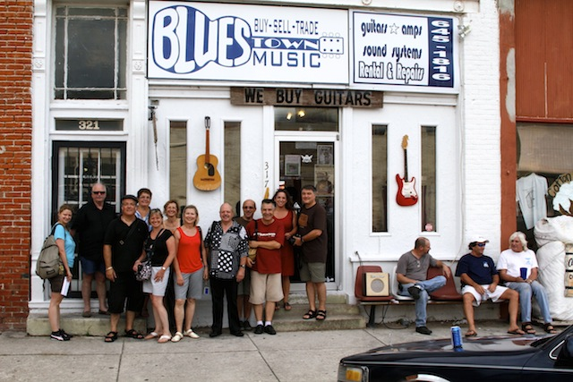

Hoi An

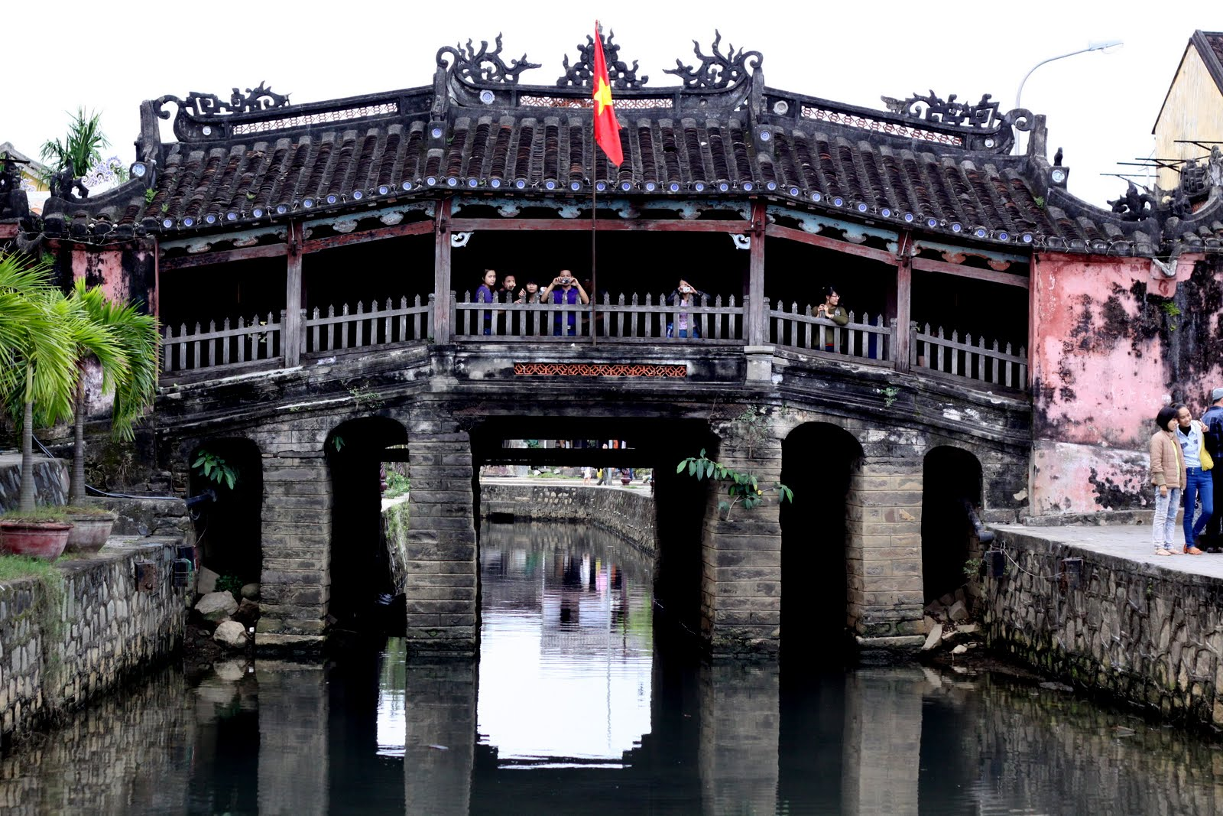

Ravenglass

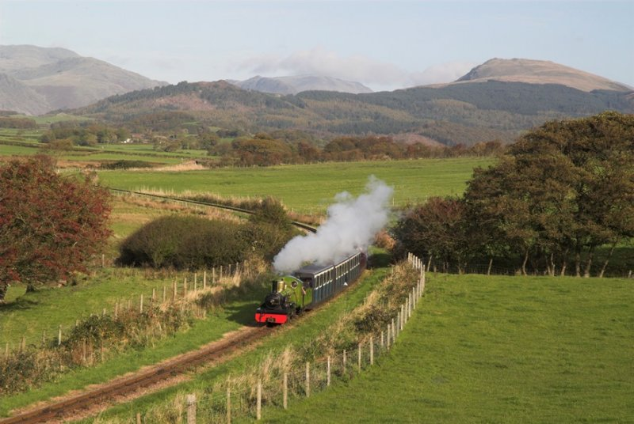

Prison converted to theatre in Bendigo

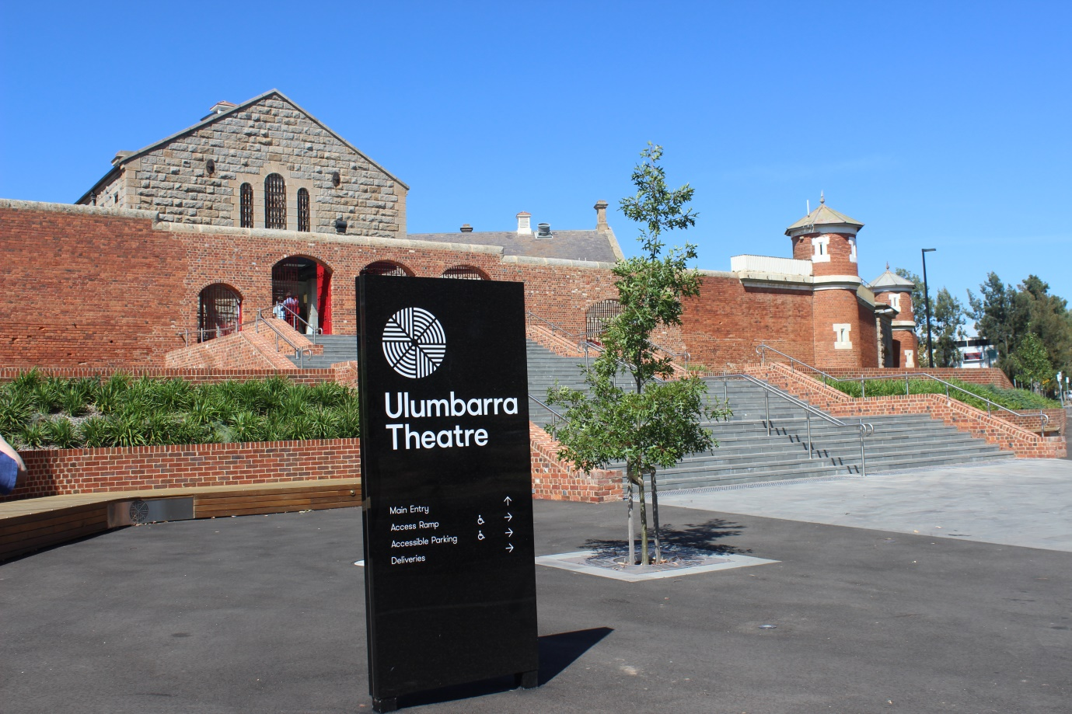

Bendigo laneway

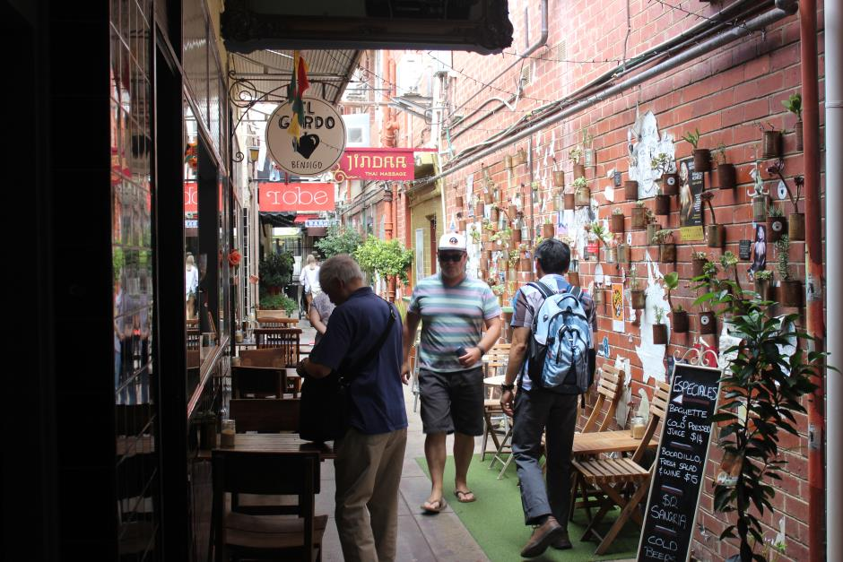

EAROPH Honorary Vice President KC Leung opening the think tank.

